St. Xavier’s College, Burdwan

Department of BCA

*A Project on online Vehicle Rental System -* TwiGo

Animesh Mondal- BCA/19/802 Arpan Ganguly - BCA/19/805

Sudisna Choudhury - BCA/19/812

Apalak Jash – BCA/19/804

ACKNOWLEDGEMENT

*The completion of this project could not have been possible without the participation and assistance of a lot of individuals contributing to this project. However, we would like to express our deep appreciation and indebtedness to our teachers* ***Mrs. Debdutta Banerjee, Mr.***

***Soumendu Banerjee, Mr. Ujjwal Mondal*** *for their endless support, kindness, and understanding during the project duration.*

We would like to thank our college and university for giving us such a big opportunity.

ABSTRACT

This report was commissioned on us to investigate and relate different functional, operational and technical requirement of a dedicated web application for online

Car rental system. This System will facilitate the functioning of web-based Rental Car store. Each type of car should have a different rental fee per day. Rental fee depends on number of day, brand and how fast the car runs. The system should have the following functionalities :Rent: The system equipped to answer Customer's inquiries about the availability and rental fee of various "types" of cars for certain dates in the future. When the customer makes a decision about the "Type“ of car and the Dates, the system should be able to "Reserve" or "Earmark“ the requested type of car for requested dates. The customer should be given a "Confirmation Number”. Pick Up: The system process a Car Pick Up. Customer walks in and supplies either the confirmation number, or name. The system should pull up all the reservation in formation about this customer. The customer is then asked to supply a drivers ‘license. Return: The system process a return. The system should record the date, time and processed by Depending on these parameters, the system calculate the final rental amount.

INTRODUCTION

VEHICLE RENTAL SYSTEM is a web based system for renters that rents out cars. This system enables the renter to make their vehicles available to the public through the internet and also keep records about their services.

The world has become a place where there is a lot of technological development; where every single thing done physically has been transformed into computerized form. Nowadays, people’s activities have been transformed into work done by computerized systems. One of which is the main target of this project which is about Car Rental System. The system of renting cars exist back in the previous years, were people rent cars for their personal reasons. Car renting is essential to many peoples’ plan to travel or move from one place to another for business purposes, tour, and visit or holidays, for these reasons Car renting is very helpful.

The starting point of Car renting is really unknown as said by Thomas Pretty; he also mentioned that many beliefs that Joe Saunders was the first man to start a Car renting company. According to Thomas Pretty, charges were calculated with the help of mileage tracking device. Many people became interested in the Car rental business and hence got involved. Car renting became more popular as years pass by. Today Car renting services is found all over the world, especially in the developed and developing countries. To make this service more popular and accessible to the public it has been transform into a web base system and connected to the internet were everyone can be able to have access to it.

OBJECTIVES

The main objective of TwiGo is:-

1. To develop a web based system that will help manage the business transactions of car renting.

2. To help in advertising the car rental services of those renters who want to avail their vehicles, through the availability of the system online.

SCOPE OF TwiGo

* The car rental system to keep detail records of both the cars and the customers, the duration they rent car as well as the type of car they rent.
* The system will be mainly designed for renters who want to avail their vehicles for renting purpose and for the customers who want to book a vehicle according to their budget, time and comfort.
* The system will have the ability to generate invoice for each successful transaction.

**Level of Access:**

The system will have three levels of access:

* Administrator
* Customer
* Renter

# STRUCTURE

*The website content:* We have used several multimedia elements to enhance the appeal and usefulness of the website.

* Images
* Documents
* Content feed from other websites including cars and other vehicles.

# SIGNIFICANCE OF THE PROJECT

* 24*7 interactions with customers.
* Saves times.
* Easy to access.
* Customer can give their feedback.
* Helpful in expansion of business for renters.
* Car for every occasion
* Affordable rates

# SYSTEM DEVELOPMENT TOOLS

## 

## **Software Tools:**

***SQL***: SQL stands for Structured Query Language. It is designed for managing data in a relational database management system (RDBMS).SQL is a database language, it is used for database creation, deletion, fetching rows, and modifying rows, etc.

***Apache****:* Apache is the most popular Web server software. It enables a computer to host one or more websites that can be accessed over the Internet using a Web browser.

***HTML****:* HTML (Hypertext Markup Language) is the code that is used to structure a web page and its content.

***PHP****:* PHP stands for Hypertext Processor. It is used to manage dynamic content, databases, session tracking, even build entire e-commerce sites.

***CSS****:* CSS stands for Cascading Style Sheet. It is the language for describing the presentation of Web pages, including colors, layout, and fonts.

***JavaScript****:* JavaScript is a text-based programming language used both on the client-side and server-side that allows you to make web pages interactive. Where HTML and CSS are languages that give structure and style to web pages, JavaScript gives web pages interactive elements that engage a user.

***Visual Studio code****:* It stands for Visual Basic Code. It is a code editor used to develop computer programs, as well as websites, web apps, web services and mobile apps.

***Firefox****:* Mozilla Firefox is nothing but a Web Browser, with which one can access the internet. The web browser lets one access information in form of text, audio, images, and videos from all around the world.

***Chrome****:* Google Chrome is a cross-platform web browser developed by Google for accessing the World Wide Web and running Web-based applications.

***XAMPP:***XAMPP is one of the widely used cross-platform web servers, which helps developers to create and test their programs on a local webserver. It was developed by the **Apache Friends**, and its native source code can be revised or modified by the audience. It consists of **Apache HTTP Server, Maria DB, and interpreter** for the different

Programming languages like PHP and Perl.***MS Word****:* Its purpose is to allow user to type and save document.

***PhpMyAdmin****:* phpMyAdmin is a free software tool written in PHP, intended to handle the administration of MySQL over the Web. PhpMyAdmin supports a wide range of operations on MySQL and Maria DB. Frequently used operations (managing databases, tables, columns, relations, indexes, users, permissions, etc.) can be performed via the user interface, while you still have the ability to directly execute any SQL statement.

***MS PowerPoint****:* This software application particularly used to present data and information by using text diagram with animation, images and transitional effect etc. in form of slide.

**Hardware Tools: -**

*A workstation server:*

Hardware configuration

***CPU****:* INTEL CORE i5 8250U

***RAM****:* 8 GB DDR4 2133Mhz ***STORAGE****:* SSD 225 GB

# ENTITY RELATIONSHIP DIAGRAM

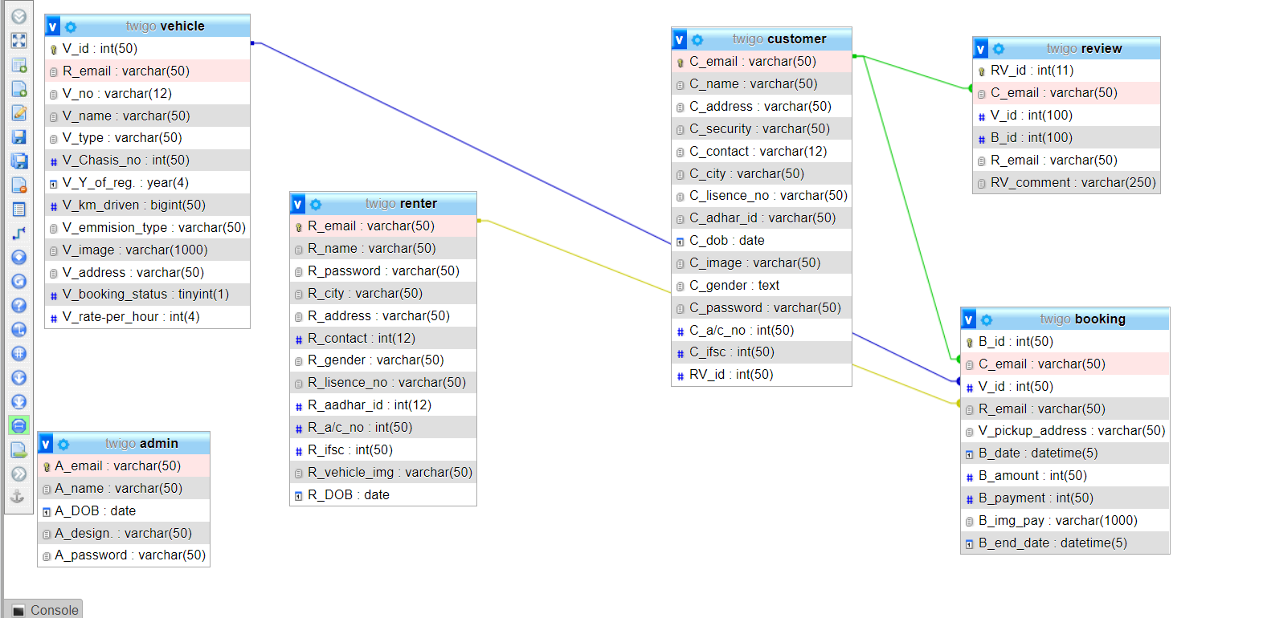

# SCHEMA

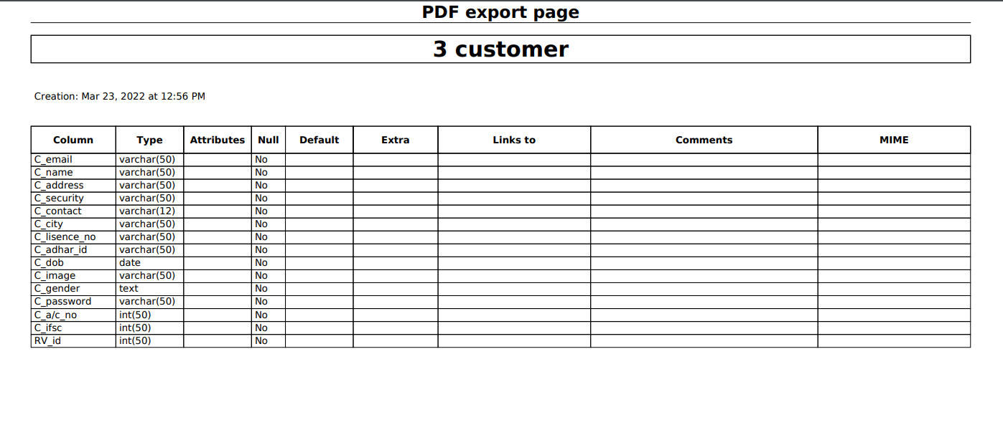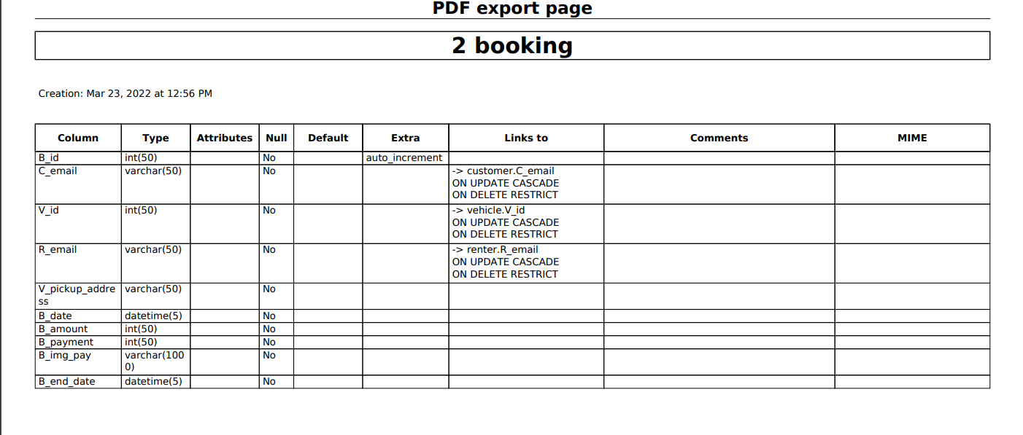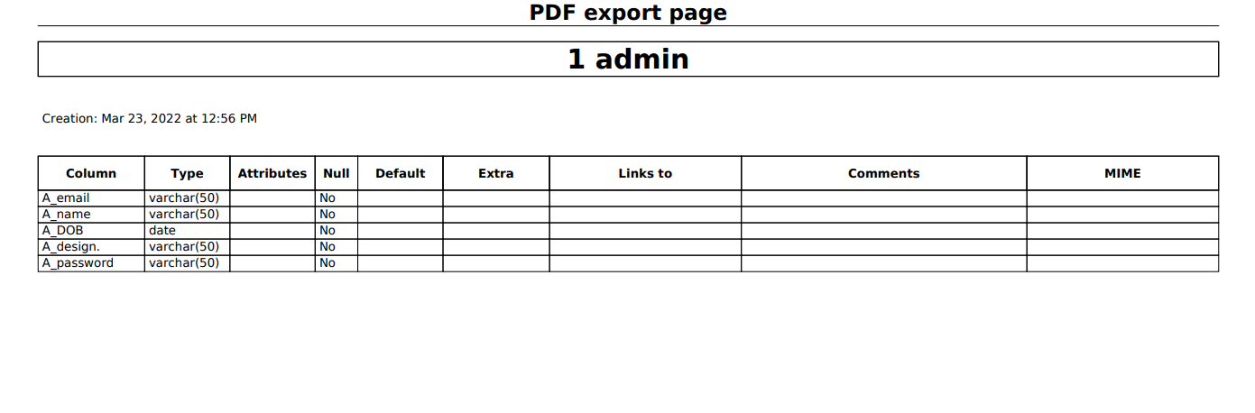

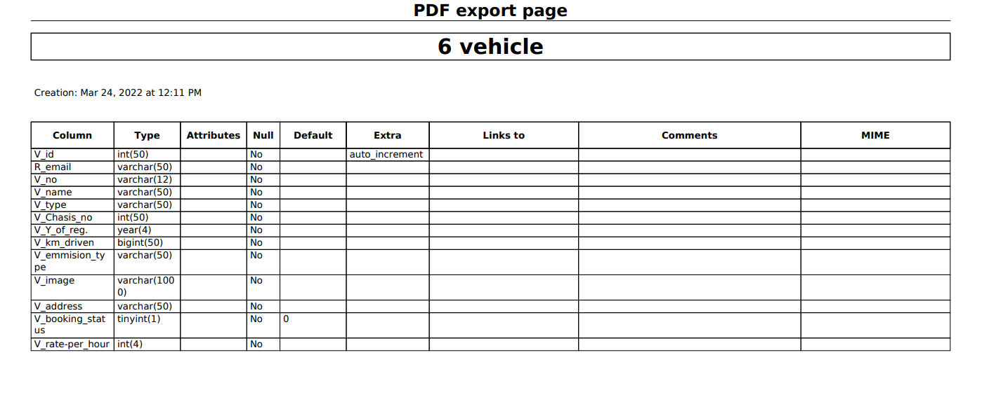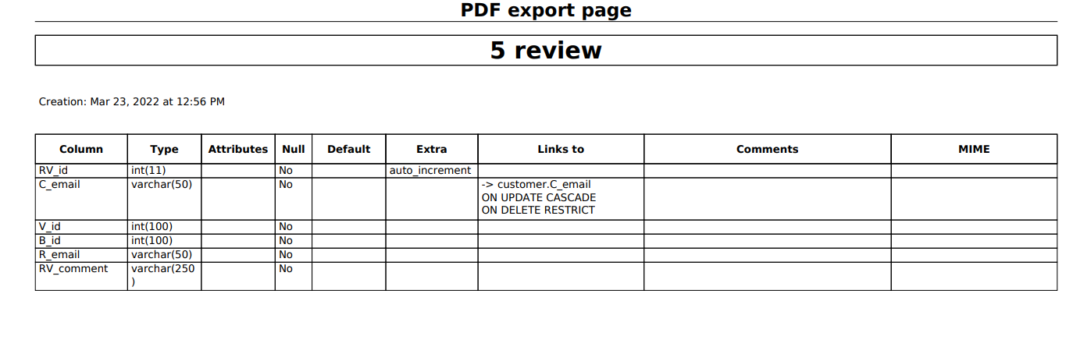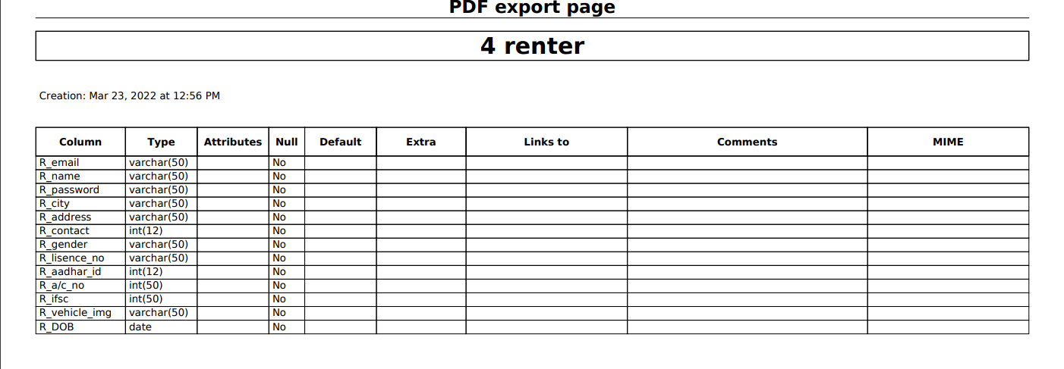

# WORKING DIRECTORY

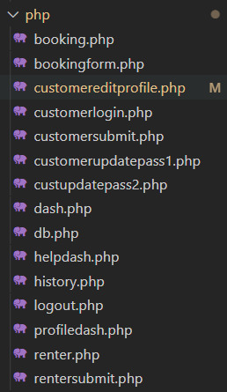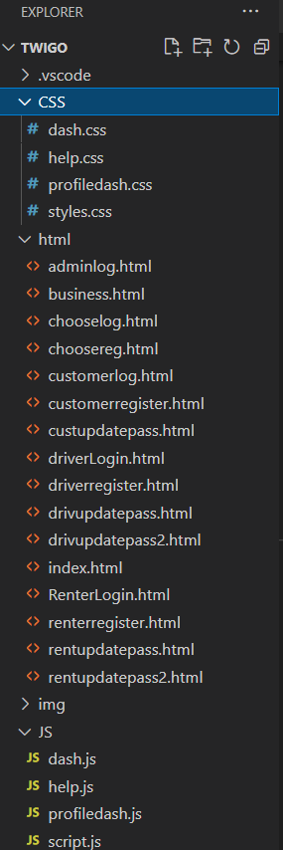

## ***Table details and sample data***

None of these data samples represent actual values present of any real person. These are all harmless dummy fictious values for better understanding through example.

***Customers Table***

This table contains details of customers who signed up.

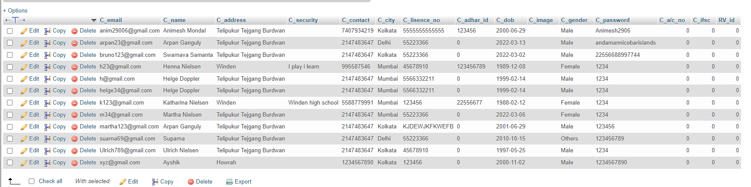

***Renter Table***

This table contains details of renters who signed up.

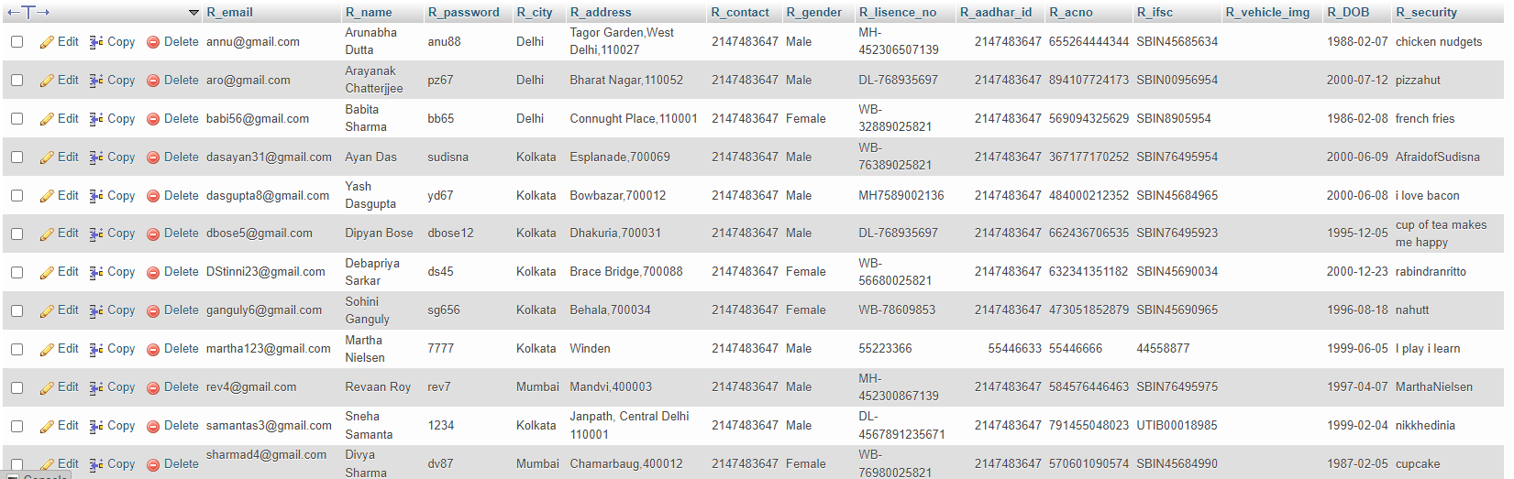

# PICTORIAL DEPICTION

## ***Home Page***

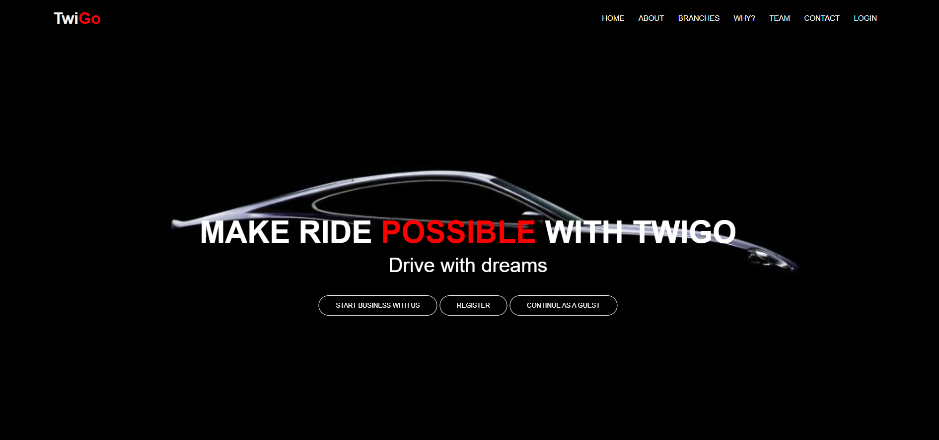

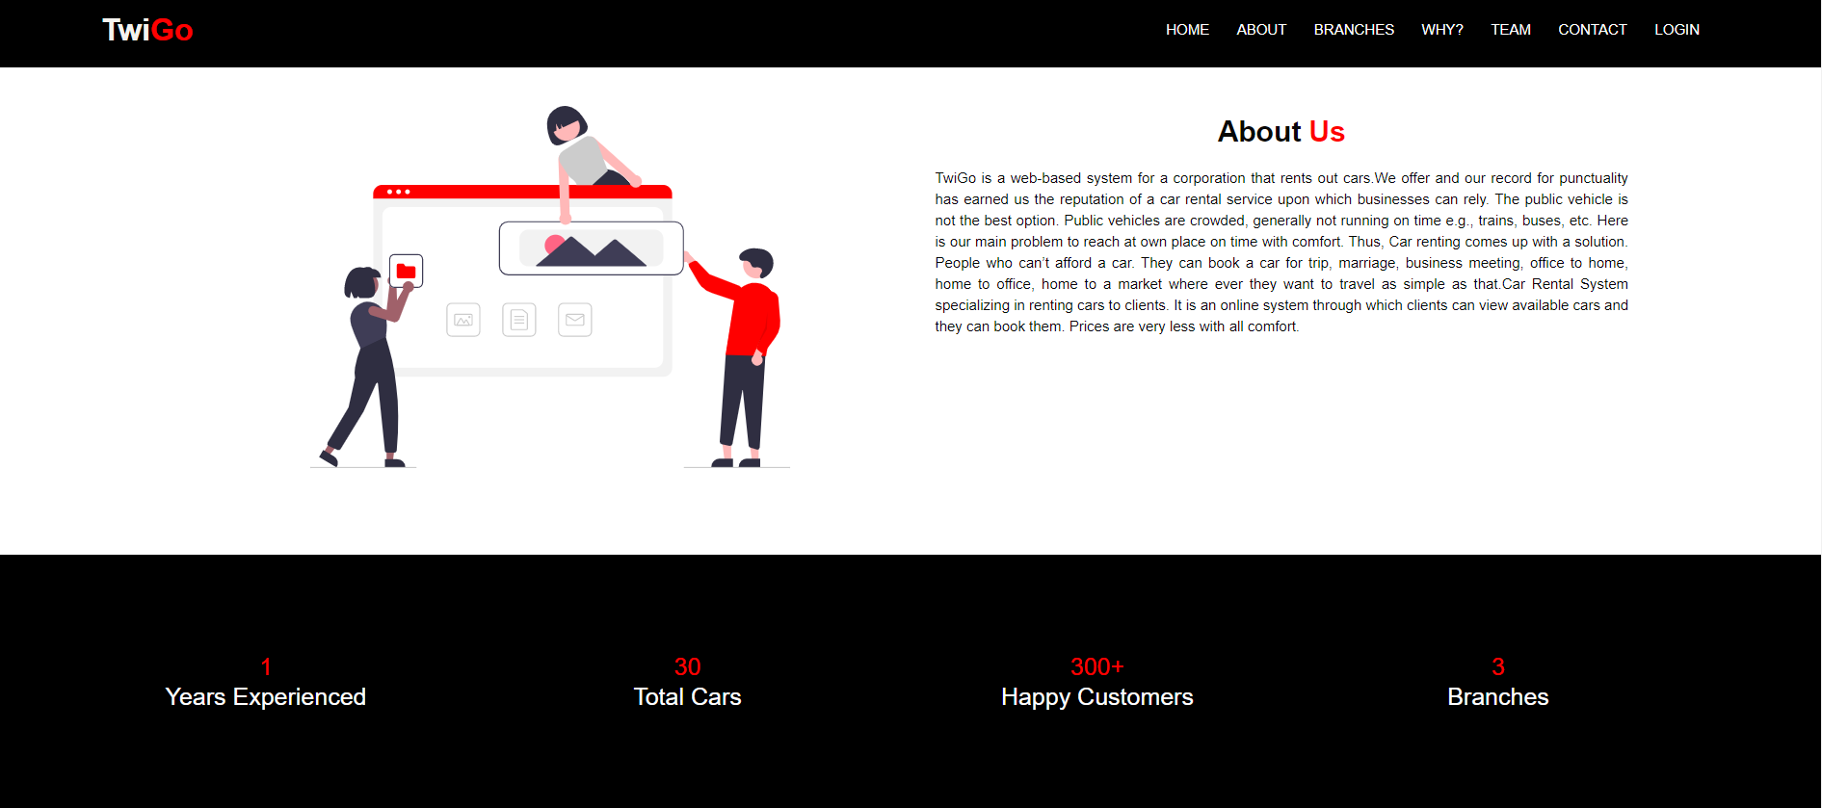***About Page***

***Branches Page***

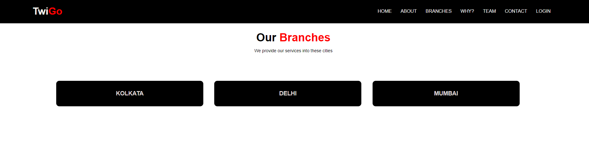

***Why TwiGo***

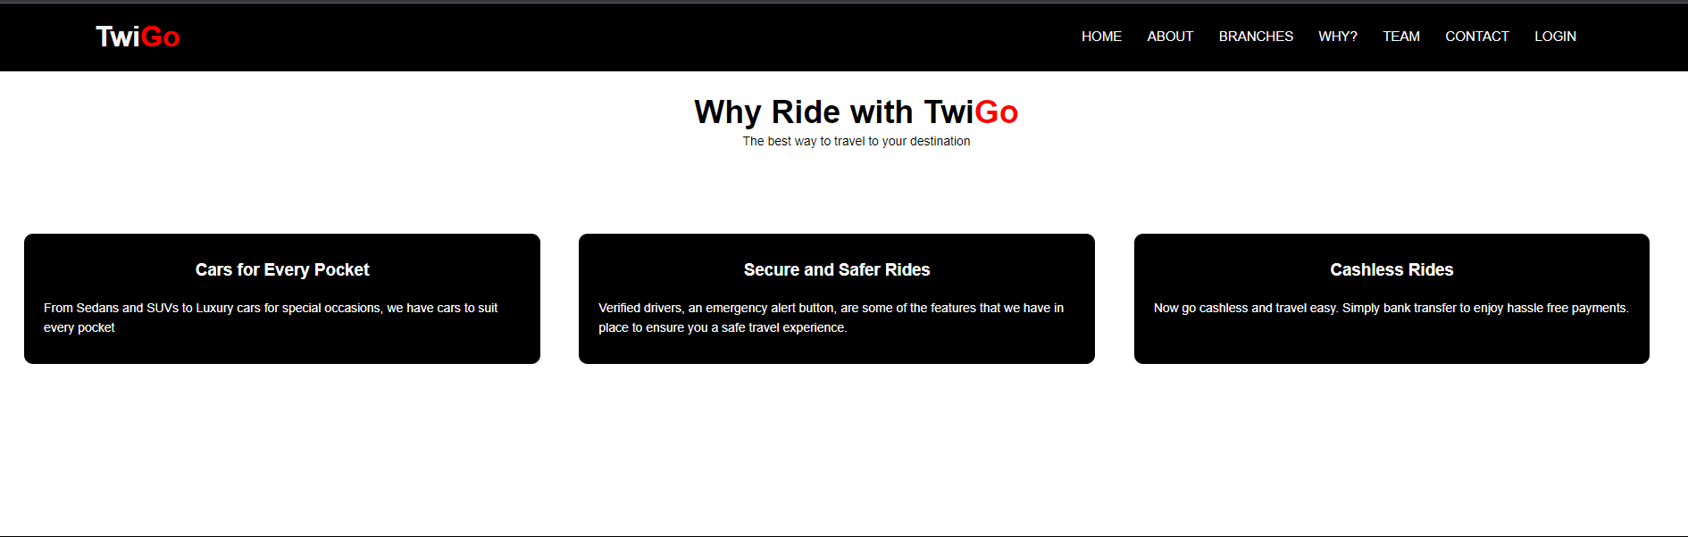

***Founders Page***

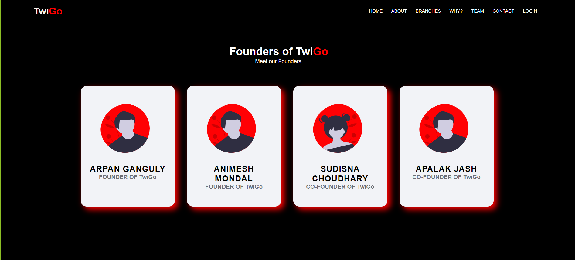

***Contact Page***

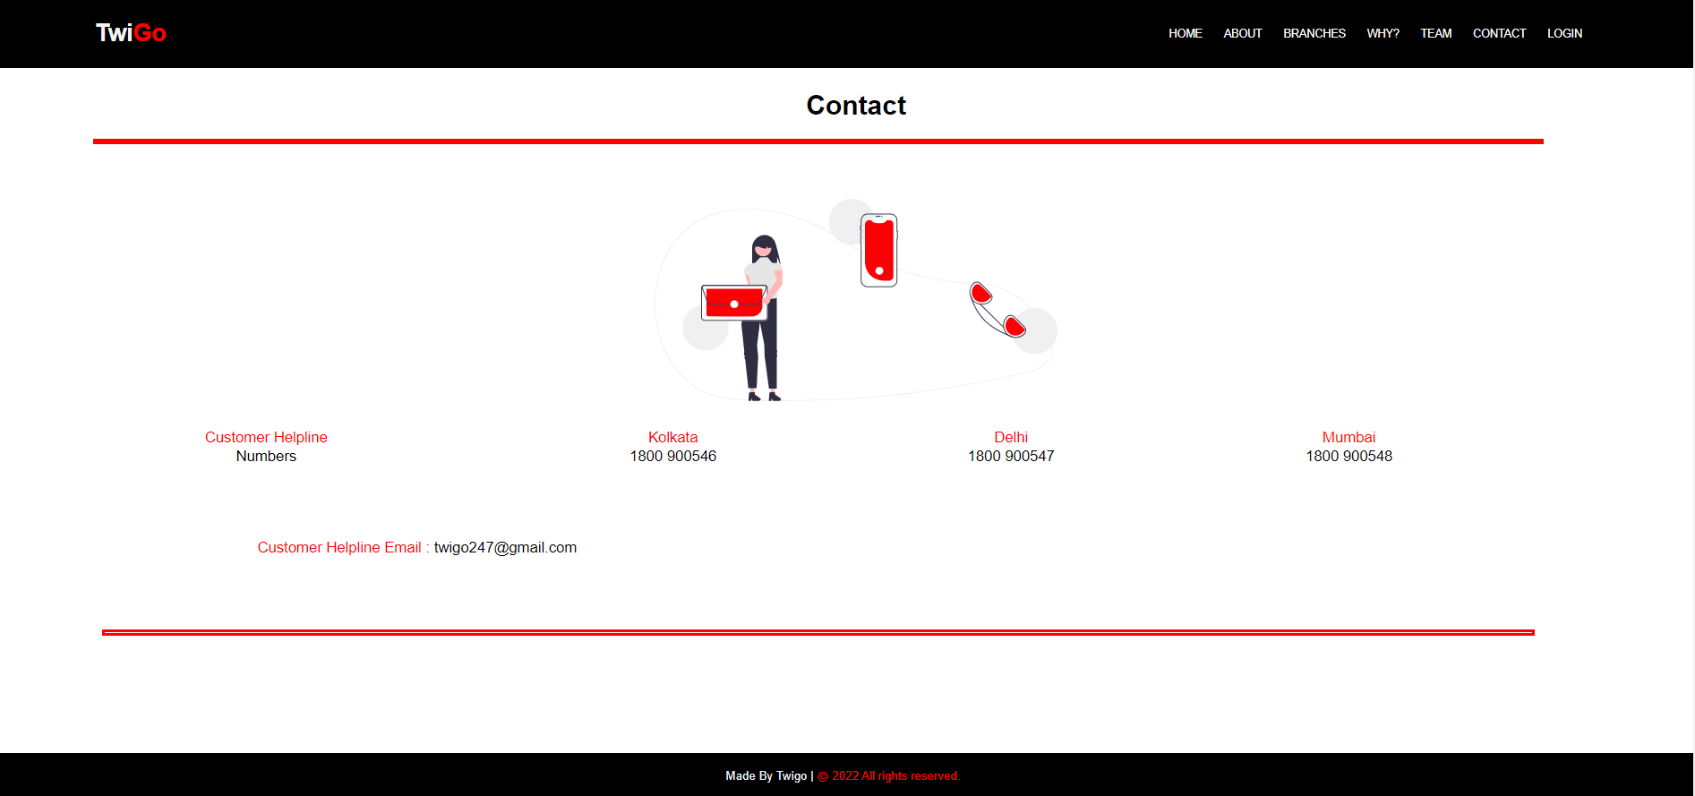

***Register Choose Page***

## 

***Customer Registration Page***

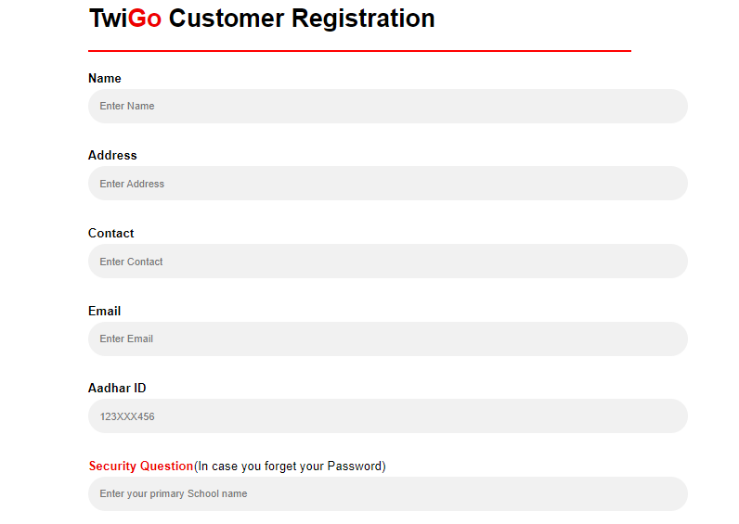

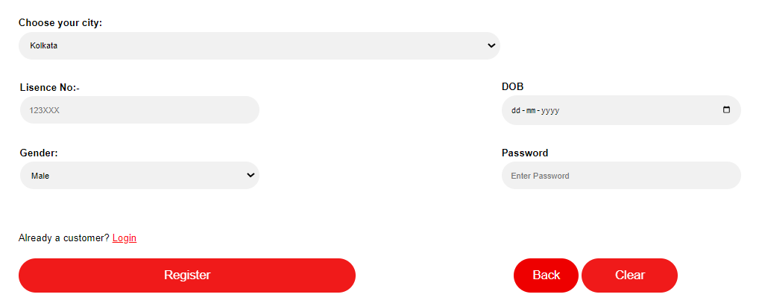

***Customer Registration Page***

